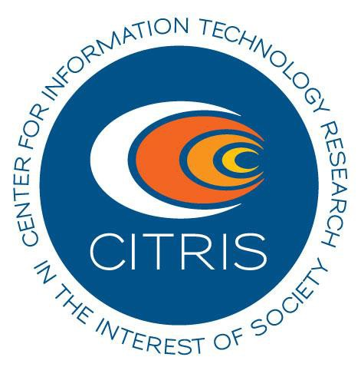CITRIS @ UC MERCED presents
“UAV Safety and Best Practices Technical Workshop”

July 7th, 2015, 0900-1700 hrs
This CITRIS sponsored technical workshop, with lunch included, will
provide six hours of instruction around safe deployment and operation of unmanned-aerial-vehicles or drones. Participants must have some experience piloting at minimum a DJI Phantom or equivalent platform, and be familiar with the AMA Safety Code1.
Course Topics to be covered include:

- Introduction to Unmanned Aerial Systems Flight Operations;
- Regulations, Operations Risk Management and Flight Simulation;
- Autonomous Flight and Data Collection;
- Navigation and Flight Planning;
- Ground Flight Operations and Safety Checks;
- Piloting Skills Assessment

Location: UC Merced Castle Research Facility, 4225 Hospital Rd Atwater, CA 95301

To apply: please send a brief description of qualifications and interest to
Dr. Joshua Viers (jviers@ucmerced.edu) by July 3rd.

1 http://www.modelaircraft.org/files/105.pdf

